Day-8 agenda

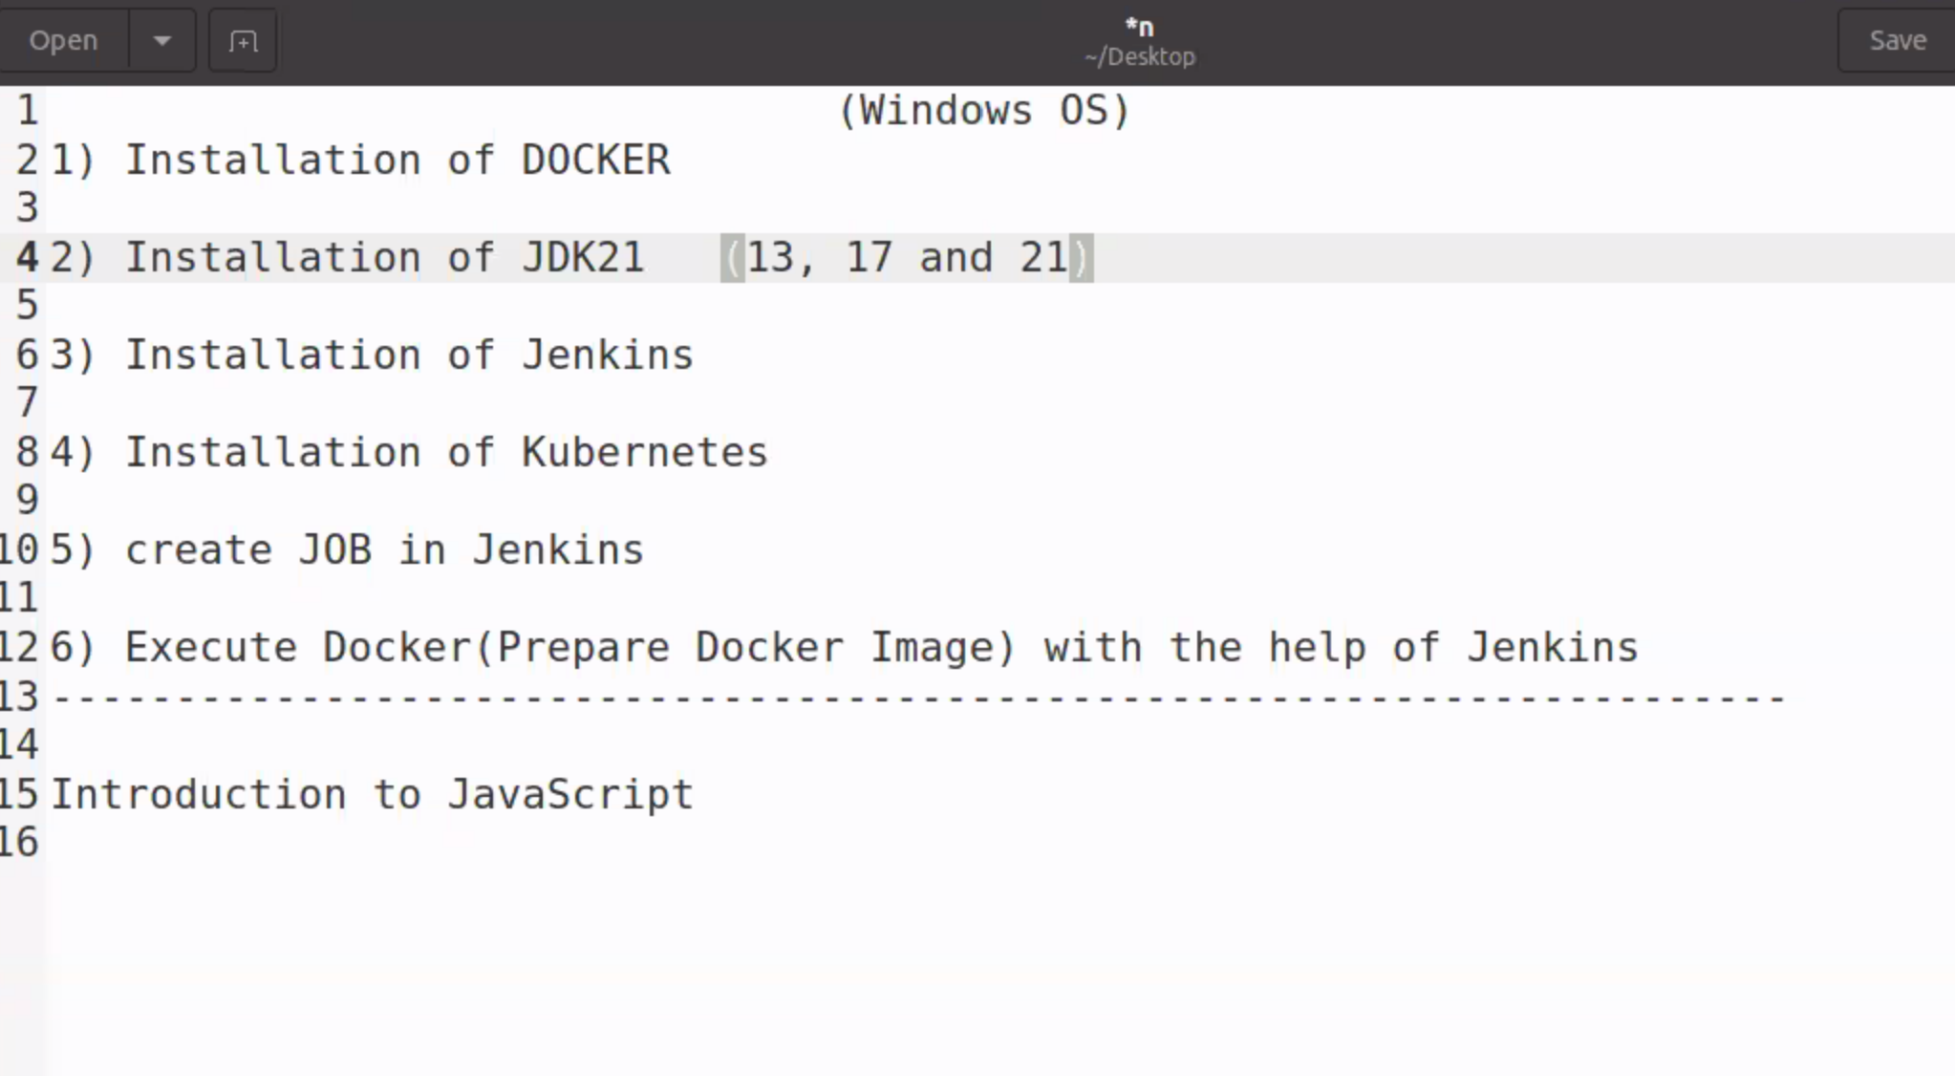

Jenkins port is mapped to 8081

To open Jenkins

<http://localhost:8081>

c drive

view show hidden files

programdata

Jenkins

.jenkins

Secrets

Intialpassword file

f19dc803381040bc8d91f4c0b364faa3

select plugin to install

install

skip and continue as admin

save and finish

install plugins

manage plugins

top left drop down

plugins

available plugins

docker

docker pipeline

after installing

restart Jenkins

install kubernettees

installed

minikube version

to rull minikube we need one shell

to work with minikube we use

kubectl software is needed

so for that go to c drive

create a new folder with name kubectl

and paste kubectl.msi file

after that go to environmental variables

don’t execute docker commsnds manually

so go to Jenkins

create a job

if commits are detected in repo in gitlab

convert docker to DockeImage

go to Jenkins

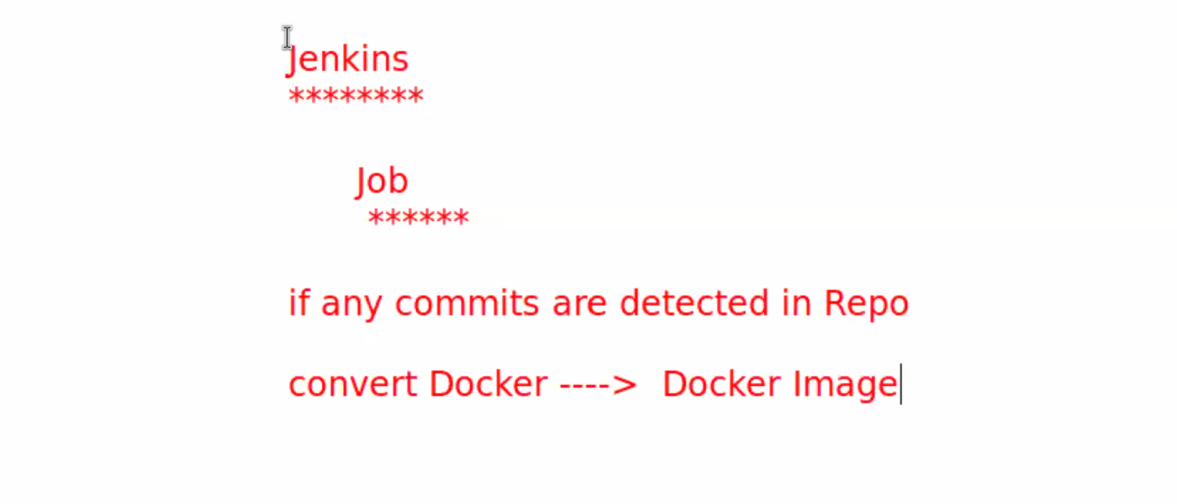

Go to Jenkins wb

Localhost:8081

Create job

Demopipline

Ok

Go to script and paste the script given

pipeline {

agent any

stages {

stage('Build Docker Image') {

steps {

script {

bat 'docker build -t simple-webpage .'

}

}

}

stage('Run Docker Container') {

steps {

script {

bat 'docker run -d -p 8082:80 simple-webpage'

}

}

}

}

}

Build now

It will fail

Now copy the files required in the location given(

C:\ProgramData\Jenkins\.jenkins\workspace\aaaa



<!DOCTYPE html>

<html lang="en">

<head>

<meta charset="UTF-8">

<meta name="viewport" content="width=device-width, initial-scale=1.0">

<title>Document</title>

<link rel="stylesheet" href="./styles.css">

</head>

<body>

<h1>hello-world</h1>

<button>click</button>

<script async src="./app.js"></script>

</body>

</html>

**Styles.css**

h1{

    color: white;

    background-color: black;

    text-align: center;

}

**App.js**

let btn = document.querySelector("button")

console.log(btn);

btn.addEventListener("click" , () => {

let h1 = document.querySelector("h1")

console.log(h1);

h1.style.color = "red"

h1.style.backgroundColor = "green"

})

**Dockerfile**

# Use an Nginx base image

FROM nginx:alpine

# Copy your web files to the Nginx directory

COPY . /usr/share/nginx/html

After pasting these files once again buildnow

It wi;l;; run

**Output**

**Localhost:8083**

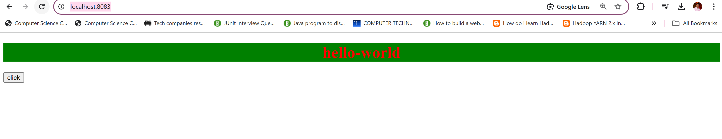

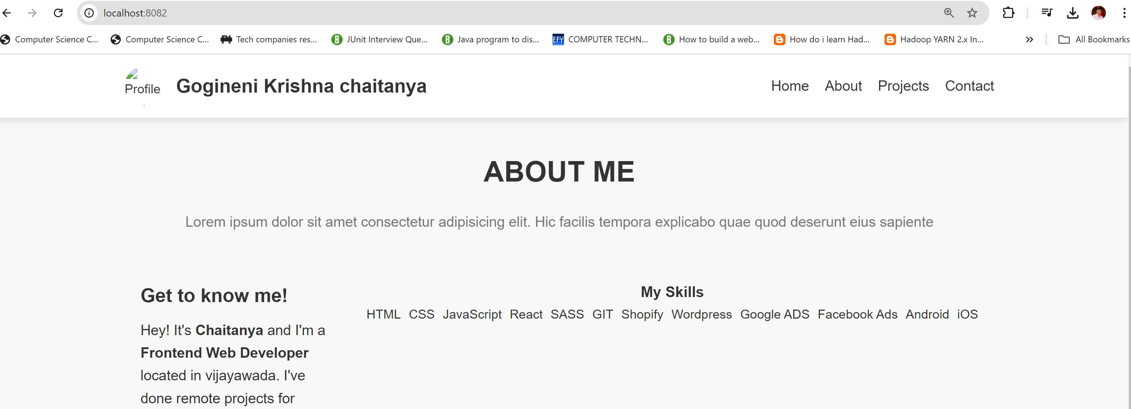

JavaScript:

It is scripting language

Used to build dynamic webpages.

Form validations help of regular expressions

Js is synchronized scripting language.

Synchronized means line by line execution.

Js is object based scripting language

Browsers- provided predefined objects

1. Document object- manipulate html elements
2. Console object-debug js application
3. Date object-work with calendar
4. Local storage- browser local storage
5. Session storage- browser session storage
6. Window object-

JS is used to develop **Client side as well as Server side** applications

**Clent side**

ReactJS

VueJs

Angular

CoffeeScript

underscoreJS

NextJs

**Server Side:**

NodeJS

ExpressJS